Background:
Reseda Charter High School, Middle School, and Magnets serves students in 6th-12th grades and is part of the Los Angeles Unified School District. Sparked by the interest of school leaders to shift the culture of the school, Reseda has been intentionally embedding and implementing the work of the Quaglia Institute since Summer 2017. An Aspirations Team composed of teachers, coordinators, and administrators receives training from the Quaglia Institute and then leads this work at Reseda; facilitating professional development for the full faculty and implements various systems of change to amplify Student Voice across the campus. In 2018, Reseda Charter was recognized as a Quaglia School of Action.
Analysis:  Our work has organically and intentionally blossomed in the following ways over time:  - Monthly Advisory Challenges aligned with the 8 Conditions  - November -Belonging  - December - Heroes  - January - Sense of Accomplishment  - February - Curiosity & Creativity  - March - Fun & Excitement  - April - Spirit of Adventure  - May - Leadership & Responsibility  - June - Confidence to Take Action  - Principal’s Advisory and Aspirations Council (PAC)  - Advisory Ambassadors Extension to the PAC (Intro Meeting)  - Student Voice and Aspirations Program (SAAP)  - Staff Professional Development  - New Teacher Student Voice and Aspirations Professional Development  - Student Voice Targeted Lessons in the Middle School  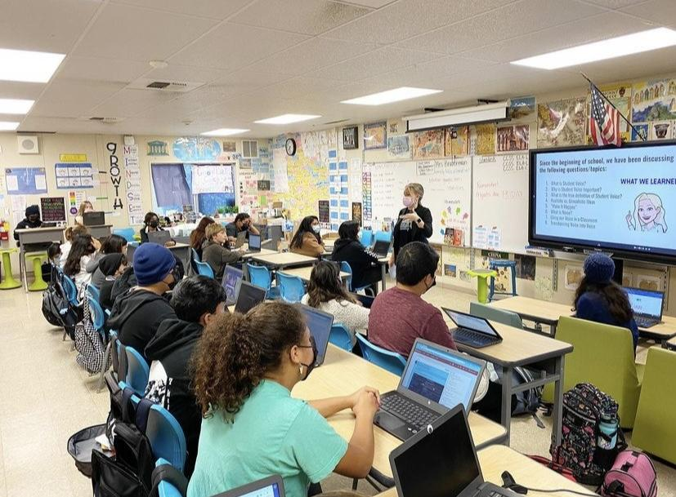  - School-wide Branding  - School Voice Survey in the Fall and Spring | Purpose:  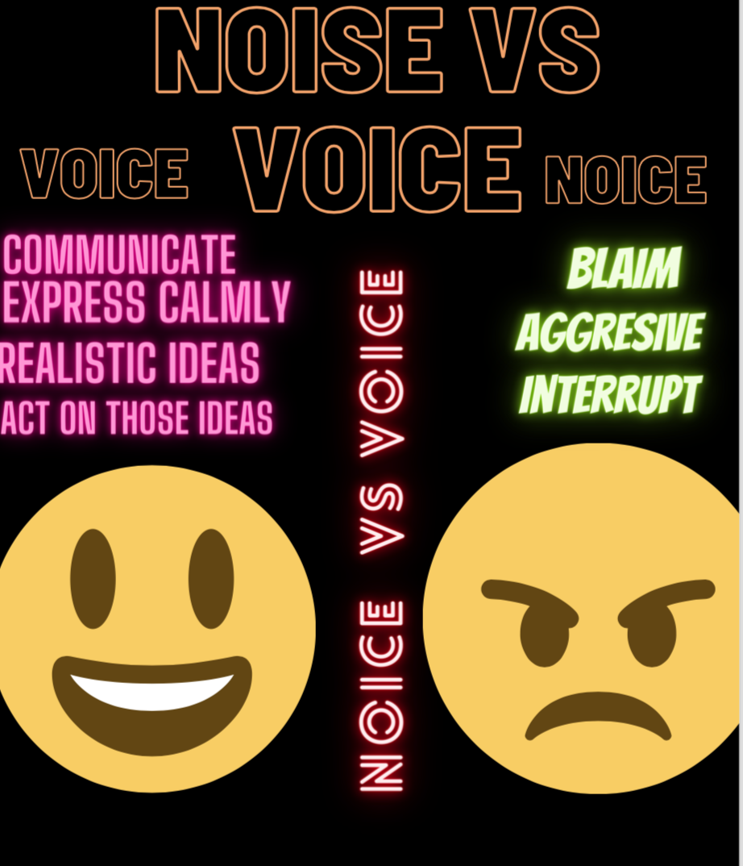  Our specific goals in the 2021-2022 school year were to continue our work school-wide, build new and returning staff capacity in the SVA work, and focus on fostering a sense of belonging school-wide as students transitioned back from distance learning as a result of the COVID pandemic.  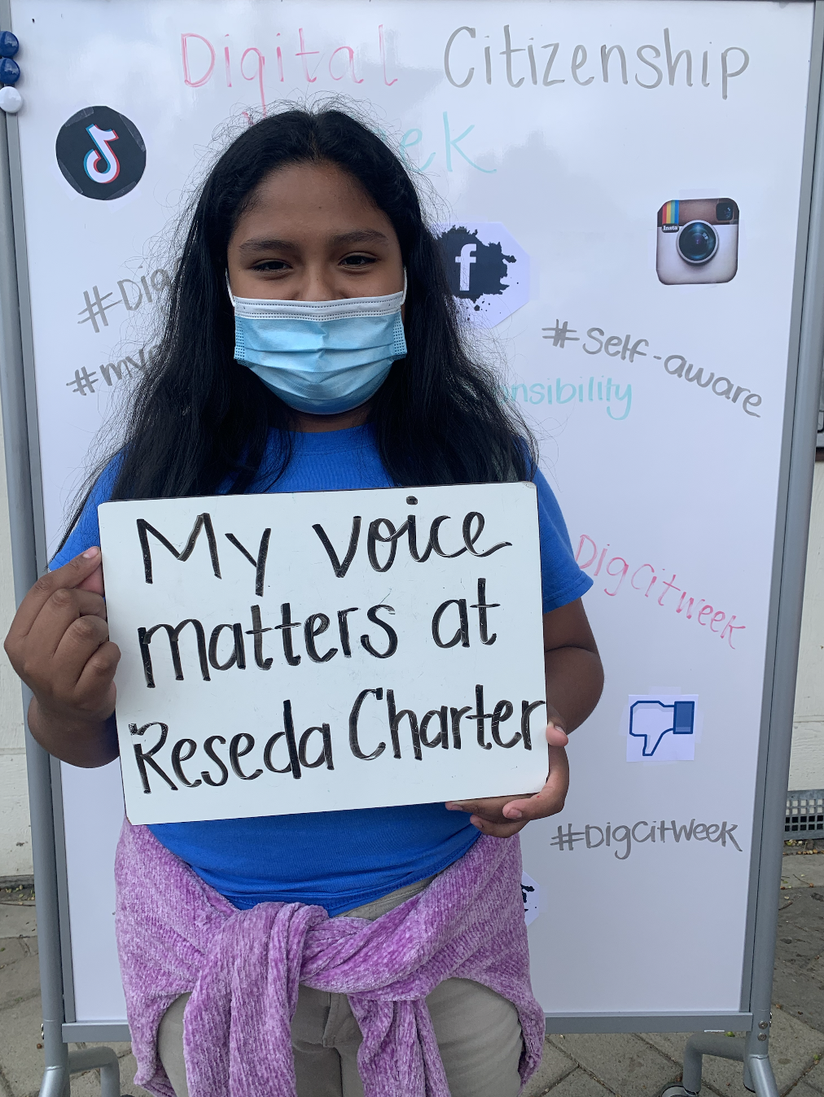
Interviews/Reflections (Adults):  “My experience with Student Voice and Aspirations has been absolutely incredible! This work has completely transformed our school culture and community. It truly laid the groundwork for us to remain connected to our students during these trying times.”  “Looking at Student Voice survey data has taught me how critical student voice, outreach, and feedback is. The Student Voice survey data really sheds light on the student experience and the disparity between adult perception and student reality. It forces you to take a hard look and tackle critical areas that can drastically improve students' experiences and successes.”  “I think the most important thing about Student Voice is helping all students realize and believe that their voice matters. I also think it is critical that students learn that student voice is about action and partnership; it is not just stating their opinion.“ | Interviews/Reflections (Students):  “I think the most important thing about student voice is that it shows that students' thoughts are valued and important to adults. Sometimes students can feel like their opinions aren't important, and student voice helps that feeling fade."  "I know my voice is valued by my teachers/coaches because they always listen to what I have to say, and they put an effort into helping me (if I need it) in any way they can."  "I think the most important thing about Student Voice is being able to reach out and get awareness for certain topics/issues. Student Voice is important because one can make suggestions and create a more inclusive space!"  "To me, Student Voice is the ability to say what's on your mind without being judged. It is about bringing students together to make an impact for the greater good."
Key Areas of Focus Moving Forward:

We will continue to embed “voice” as part of our operational processes moving forward. We will strive to continue our work to make Student Voice a way of being at Reseda. We will continue to build our language, practices, and policies around this work. We will continue to really take time to teach the power of voice to all students and support them in developing skills and confidence to use their voice. We will strive to establish school onboarding for incoming students to introduce Student Voice as it’s embedded in our culture. Reseda will strive to value the perspectives and opinions of students, teachers and parents, and to act on them in a way that genuinely shapes decision-making and learning at the school.
